A Dissertation Report
on
Cardamom Leaf Disease Detection Using Deep Learning
An Explainable AI Approach with EfficientNetV2 and Grad CAM
Submitted in partial fulfillment of the requirements
Of
Master Of Computer Application (MCA)
Submitted to:

Purbanchal University
Faculty of Science and Technology
Biratnagar, Nepal

Submitted By:
Darpan Subedi
Exam Roll No: 340061
Registration No. 025-3-3-07537-2017

Under Supervision of
Mr. Raju Kattel
Associate Professor
Kantipur city college
Putalisadak, Kathmandu

June, 2026

LETTER OF APPROVAL
It is hereby informed that the topic selected by Mr. Darpan Subedi of Master of Computer Application (MCA) IVth semester for his Dissertation has been found suitable and as per the credit assigned for the Dissertation to be done for the fulfillment of the requirements for the award of the degree of Master of Computer Application (MCA) of Purbanchal University (PU), Biratnagar, Nepal.
The research committee has finally approved the following topic and supervisor for the above-mentioned candidate.
Topic Approved: “Cardamom Leaf Disease Detection Using Deep Learning - An Explainable AI Approach with EfficientNetV2 and Grad CAM”
_________________  Raju Kattel  Associate Professor  Department of Science and Technology  Kantipur City College  Purbanchal University  (Dissertation Supervisor) | _____________________  Er. Bhanu Bhakta Niroula  Vice-Principal  Kantipur City College
Place: Kantipur City College, Putalisadak, Kathmandu
Date: 10th Feb 2026

CERTIFICATE FROM SUPERVISOR
This is to certify that the Dissertation Report entitled “Cardamom Leaf Disease Detection Using Deep Learning An Explainable - AI Approach with EfficientNetV2 and Grad CAM” Symbol Number: 340061 and Registration Number: 025-3-3-07537-2017 to the Department of Computer Application and IT, Kantipur City College, Kathmandu, Nepal towards the partial fulfillment of the requirement for Master of Computer Application (MCA) is an original work carried out by him and meets all the requirements defined by the university to award the degree.

Raju Kattel
Associate Professor
Department of Science and Technology
Kantipur City College
Purbanchal University
(Dissertation Supervisor)

Place: Kantipur City College, Putalisadak, Kathmandu
Date: 20th June 2026

CERTIFICATE FROM EVALUATING TEAM
This is to certify that the Dissertation Report “Cardamom Leaf Disease Detection Using Deep Learning An Explainable - AI Approach with EfficientNetV2 and Grad CAM” submitted by Mr. Darpan Subedi Symbol Number: 340061 and Registration Number: 025-3-3-07537-2017 to the Department of Computer Application and IT, Kathmandu, Nepal towards the partial fulfillment of the requirement for Master of Computer Application (MCA) is an original work carried out by him and meets all the requirements defined by the university to award the degree.
__________________  Signature  Mr Raju Kattel  Associate Professor  Department of Science and Technology  Kantipur City College  Purbanchal University  (Dissertation Supervisor) | ____________________  Signature  Dr. Pawan Kumar Jha  Professor, PUSAT  Biratnagar, Nepal  (External Examiner)
____________________
Signature
Er. Bhanu Bhakta Niroula
Vice-Principal
Kantipur City College

Place: Kantipur City College, Putalisadak, Kathmandu
Date: 20th June 2026

AKNOWLEDGEMENT
I would like to express my sincere gratitude to my dissertation supervisor Mr. Raju kattel for his unwavering support, guidance, and patience during this research process. His expertise, encouragement, and feedback have been very helpful in shaping my thesis.
I am also indebted to Dr. Gajendra Sharma for his valuable input, feedback, and encouragement. My special gratitude goes to Er. Bhanu Bhakta Niroula (Vice Principal Kantipur City College) for continuously pushing, suggesting, and providing a learning opportunity during the process.
Special thanks go to my family members for their support, encouragement, and love which pushed me to complete my thesis.
Darpan Subedi

Abstract
Cardamom is an economically important crop in nepal, where fungal disease mostly collects Colletotrichum Blight and Phyllosticta Leaf Spot cause yield losses among small farming communities of remote hill region. Cardamom diseases, particularly blight, can cause substantial yield losses, with reported estimates reaching approximately 30 - 40% under severe disease conditions. Due to untimely disease detection and scarcity of plant pathology experts, the farmers face a huge problem. This thesis presents the design, implementation and rigorous empirical evaluation of intelligent system for cardamom leaf disease detection, extending the work of Sunil et. al. (2022). The system developed employs Efficient V2 - S fine-tuned with transfer learning on curated dataset of approximately 2607 labeled cardamom leaf images across four classes (Colletotrichum Blight, Phyllosticta Leaf Spot, Healthy, and Other), with data sourced from Sunil et al (2022) Kaggle repository and “Other” class supplemented from additional Kaggle sources. Training was conducted on Apple’s MPS hardware over 50 epochs. The trained model achieved 99.74% overall accuracy on the 391-sample held out test set. Fivefold stratified cross - validation, background removal ablation study, robustness testing , Grad Cam ++ visual explanations and 5 stage heuristic severity estimation module were implemented on both mobile and web applications. The system is deployed as FastAPI REST backend, a React TypeScript web application and a React Native Mobile application with comprehensive bilingual English / Nepali disease management guidance.

Keywords: cardamom, leaf disease detection, EfficientNetV2, transfer learning, Grad-CAM++, 5-fold cross-validation, ablation study, FastAPI, React Native, precision agriculture, Nepal, bilingual interface, explainable AI
Table of Contents
LETTER OF APPROVAL II
CERTIFICATE FROM SUPERVISOR III
CERTIFICATE FROM EVALUATING TEAM IV
AKNOWLEDGEMENT V
Abstract VI
List Of Acronyms X
List Of Figures XI
List Of Tables XII
Chapter 1: Introduction 1
1.1 Background and Motivation 1
1.2 Problem Statement 2
1.3 Research Objectives 3
1.4 Scope and Delimitations 3
1.5 Original Contributions 4
Chapter 2: Literature Review 5
2.1 Deep Learning for Plant Disease Detection 5
2.2 EfficientNet and EfficientNetV2 5
2.3 Transfer Learning for Small Agricultural Datasets 6
2.4 Grad-CAM and Grad-CAM++ 7
2.5 Background Removal and Preprocessing 8
2.6 Plant Disease Severity Estimation 8
2.7 Mobile and Web Deployment in Agricultural AI 9
2.8 Cardamom in Nepal: Agricultural and Economic Context 9
2.9 Critical Summary and Research Gap 10
Chapter 3: Methodology 11
3.1 Research Design 11
3.2 Dataset 12
3.2.1 Primary Data Source 12
3.2.2 “Other” Class 12
3.2.3 Dataset Composition and Statistics 13
3.2.4 Dataset Split and Class Distribution 14
3.2.5 Class Imbalance Handling 15
3.3 Preprocessing 15
3.4 Dataset Source Bias 16
3.5 Heuristic Severity Approximation Using Grad-CAM 16
3.6 Model Architecture 17
3.7 Training Configuration 18
3.8 Evaluation Design 19
3.8.1 Held-Out Test Evaluation 19
3.8.2 5-Fold Stratified Cross-Validation 19
3.8.3 Background-Removal Ablation Study 19
3.8.4 Error Analysis 20
3.8.5 Robustness Testing 20
Chapter 4: System Design And Implementation 20
4.1 System Architecture Overview 20
4.2 Backend: Model and Inference Engine 22
4.2.1 Disease Classifier 22
4.2.2 Grad-CAM and Grad-CAM++ Implementation 23
4.2.3 Severity Estimation 24
4.3 Backend: FastAPI API Layer 24
4.4 Web Application 25
4.5 Mobile Application 26
4.6 System Deployment 27
4.7 Offline and Low-Bandwidth Deployment Considerations 27
Chapter 5: Results, Analysis, And Discussion 28
5.1 Training Behavior 28
5.2 Held-Out Test Set Evaluation 29
5.2.1 Confusion Matrix 29
5.2.2 Effect of Class Imbalance on Evaluation 30
5.2.3 Per-Class Metrics 30
5.3 5-Fold Stratified Cross-Validation 31
5.4 Background-Removal Ablation Study 33
5.5 Interpretation of Severity Output 35
5.6 Error Analysis 35
5.7 Robustness Evaluation 37
5.8 Critical Interpretation of Results 38
5.8.1 Near-Perfect Cross-Validation Metrics 38
5.8.2 The Single Misclassification 39
5.8.3 Comparison With Sunil et al. (2022) Baseline 40
5.9 Grad-CAM Explainability Analysis 41
5.10 Severity Estimation Analysis 42
5.11 Evaluation Acceptance Criteria Summary 42
Chapter 6: Conclusion And Future Work 43
6.1 Summary of Work 43
6.2 Key Findings 43
6.3 Limitations 44
6.3.1 Dataset Provenance and Generalization 44
6.3.2 Heuristic Severity Estimation 45
6.3.3 Network Connectivity Dependency 45
6.3.4 Blur Sensitivity 45
6.3.5 No Formal User Study 46
6.3.6 Class Imbalance 46
6.3.7 Caution on Cross – Validation Results 46
6.4 Ethics and Responsible AI Considerations 46
6.5 Future Work 47
6.6 Final Remarks 48
References 49
Appendices 53
Appendix A: Repository Structure 53
Appendix B: Complete Training Hyperparameter Configuration 55
Appendix C: Raw Cross-Validation JSON Summary 57
Appendix D: Raw Ablation Study JSON Summary 58
Appendix E: API Endpoint Specification 59
Appendix F: Class Label Mapping 61
Appendix G: Sample API JSON Responses 62
Appendix H: Mobile Application Screenshots 64

List Of Acronyms

CNN | Convolutional Neural Network
AI | Artificial Intelligence
API | Application Programming Interface
UI | User Interface
UX | User Experience
Grad-CAM | Gradient-weighted Class Activation Mapping
XAI | Explainable Artificial Intelligence
RGB | Red, Green, Blue
JSON | JavaScript Object Notation
REST | Representational State Transfer
CNN | Convolutional Neural Network
U²-Net | U-squared Network
DOI | Digital Object Identifier

List Of Figures
Figure No. | Description
Figure 1 | Model Architecture Overview
Figure 2 | System Architecture: Three-Tier Client–Server Design.
Figure 3 | Web Application Image Upload
Figure 4 | Web Application Results Panel with Grad-CAM
Figure 5 | Training And Validation Loss Curves Over 50 Epochs
Figure 6 | Confusion Matrix on The Held-Out Test Set
Figure 7 | Per-Class Precision, Recall, And F1-Score Bar Chart
Figure 8 | Model Robustness Under Perturbations Bar Chart
Figure 9 | Confidence Distribution Histogram: Correct Vs. Incorrect Predictions

List Of Tables
Table No. | Description
Table 1 | Comparative Overview Of Selected Plant Disease Detection Studies
Table 2 | Dataset Composition By Class, Source, And Data Split
Table 3 | Data Augmentation Transforms Applied To The Training Split Only
Table 4 | Training Hyperparameter Configuration
Table 5 | Technology Stack Summary
Table 6 | Severity Stage Classification Scheme
Table 7 | Backend Predict Endpoints Fields
Table 8 | Test-Set Confusion Matrix
Table 9 | Test-Set Per-Class Evaluation Metrics
Table 10 | 5-Fold Cross-Validation Results Per Fold And Aggregate Statistics
Table 11 | Background-Removal Ablation Study
Table 12 | Error Analysis Summary
Table 13 | Robustness Test Results Under Nine Perturbation Conditions
Table 14 | Comparison Of Present System With Sunil Et Al. (2022) Baseline
Table 15 | Evaluation Acceptance Criteria And Outcomes

Chapter 1: Introduction

1.1 Background and Motivation
Agriculture is economic and social backbone of nepal, sustaining livelihoods of more than 60% of the population of nepal which contributes 24% of GDP. Large cardamom occupies has a exceptional economic importance. Nepal is the world’s third largest producer of large cardamom, with mostly production centered on districts like Taplejung, Panchthar, Illam and Dhankuta, where it functions as the primary cash crops for many small households’ farmers. Despite its economic centrality, cardamom cultivation is threatened by fungal diseases. Colletotrichum blight cause anthracnose type blight with characteristics of light brown centers and dark margins around the leaves. Phyllosticta Spot cause a elliptical leaf spots with tan or gray centers frequently surrounded by chlorotic halos. In worst conditions, Colletotrichum Blight alone can cause 30-40% of yield losses. These two fungal diseases are among the most economically damaging threats to cardamom cultivation in Nepal.
The core challenge is however of access. Traditionally diseases identification depended on visual inspection by plant pathologists or experts, which seem to be problem now on remote hilly areas as there is lack of experts and resources on these areas. The visual similarity between Blight and Spot is almost indistinguishable even for attentive farmers which bring a need for specialists and experts. By the time a diagnosis is obtained through conventional methods, the infection may spread sufficiently.
Deep learning, mobile computing and cloud services however has created a technically credible pathway to automated, accessible and field deployable ready to use plant diseases diagnose system. Research done by Sunil et al. (2022) demonstrated that EfficientNet V2-L achieved 98.26% accuracy on field collected cardamom leaf disease dataset. However, their contribution remained a research artifact: a trained model but with no mobile interface for farmers. Furthermore their study also did not address explainability, linguistic accessibility, severity estimation, robustness under real world image quality conditions.
This study directly address these gaps transforming the research foundations laid by Sunil et al.(2022) into a deployed, interpretable, bilingual system, evaluated across multiple empirical protocols and designed by practical adoption of the system by Nepal’s cardamom farming communities.

1.2 Problem Statement
The central problem addressed by this study are as follows:
Diagnostic barrier: Farmers cannot reliably distinguish Colletotrichum Blight, Phyllosticta Leaf Spot and healthy cardamom leaves from just only the visual inspection, mostly the problem arises in early disease stages, and access to experts’ diagnosis is also infeasible in remote hilly areas.
Deployment barrier: The previous research work on cardamom disease detection (Sunil et al.2022) remains confined to a research model with no mobile interface, resulting in difficulty on a real-world diagnostic solution.
Interpretability, Explainability & Linguistic barrier: In many AI-based agricultural systems farmers receive predictions or recommendations without understanding how they were generated. This lack of transparency can reduce trust and make farmers hesitant to rely on the technology. In addition, most existing agricultural AI solutions do not provide interfaces in the Nepali language. As a result, Nepali-speaking farmers face difficulties in understanding and using these tools effectively, creating a major accessibility barrier for the very users who could benefit from them the most.

1.3 Research Objectives
- To build and train high accuracy EfficientNetV2 - S classifier with transfer learning for four class cardamom leaf disease classification, targeting overall test accuracy above 85%.
- To evaluate generally generalization, reliability, usability through 5-fold stratified cross-validation, held-out test evaluation, a background-removal ablation study, error analysis, and perturbation robustness testing under nine conditions.
- To implement Grad CAM and Grad CAM++ visual explanations integrated on full stack deployment on both mobile and web applications.

1.4 Scope and Delimitations
This study covers the complete development process of an AI-based cardamom leaf disease detection system, from dataset preparation and model training to deployment as a bilingual (English and Nepali) web and mobile application. The system is designed to classify cardamom leaf images into four categories and provide disease-related information to users.
The study does not cover disease detection for other crop species. It is limited to the EfficientNetV2-S model and does not investigate larger variants such as EfficientNetV2-M or EfficientNetV2-L. Full fine-tuning of U²-Net for image segmentation is also outside the scope of this research. Additionally, the system is not designed for real-time video processing and does not provide professional agronomic treatment recommendations. Instead, it offers structured informational guidance to help farmers better understand identified diseases.

1.5 Original Contributions
This research makes several contributions to the field of cardamom disease detection and agricultural AI:
Comprehensive Evaluation Framework: The proposed system is evaluated using 5-fold cross-validation, background-removal ablation studies, detailed error analysis, and robustness testing under nine different image conditions. These evaluation methods were not included in the work of Sunil et al. (2022).
Expanded Disease Classification Scheme: An additional "Other" class is introduced to identify images that do not belong to any target disease category, making the system more reliable in real-world deployment.
Integrated Explainable AI Features: A heuristic visual severity indicator based on Grad-CAM attention regions, intended to support interpretability rather than provide clinically or agronomically validated lesion measurement.
Disease Severity Estimation: A heuristic severity estimation module is developed to approximate disease extent using a five-stage severity scale, providing users with additional insight beyond disease identification.
Bilingual Full-Stack Deployment: The research presents a complete English-Nepali bilingual disease detection system with Nepali-language guidance, improving accessibility for local farmers.
Reproducible Research Pipeline: The entire training and evaluation process is documented with fixed random seeds, clearly defined data augmentation strategies, and an open-source implementation to support reproducibility and future research.1.6 Thesis Structure

Chapter 2: Literature Review

2.1 Deep Learning for Plant Disease Detection
The foundational contribution of Mohanty et al. (2016) established the viability of CNN-based plant disease detection by demonstrating 99.35% accuracy on the PlantVillage dataset, a benchmark comprising 54,306 labeled images across 26 disease classes and 14 crop species, captured under controlled laboratory conditions. This result generated substantial research momentum but was critically qualified by subsequent work: Barbedo (2018) conducted a systematic review identifying background complexity, illumination inconsistency, and intra-class visual heterogeneity as the primary sources of the generalization gap between laboratory and field performance, arguing that controlled-condition benchmarks overstate deployable performance by a substantial margin.
Thapa et al. (2020) addressed this gap through the PlantDoc dataset, comprising 2,598 images collected under diverse real-world conditions across 13 plant species and 17 diseases. Models evaluated on PlantDoc consistently achieved substantially lower accuracy than on PlantVillage, reinforcing the necessity of field-collected training data for deployment-readiness, a principle directly informing the dataset strategy adopted in this thesis.
Ferentinos (2018) performed a comprehensive architectural comparison on PlantVillage, confirming that transfer learning with ImageNet-pretrained weights consistently outperformed training from scratch across all architectures tested, a finding that provides theoretical grounding for the transfer-learning approach employed here.

2.2 EfficientNet and EfficientNetV2
EfficientNet, introduced by Tan and Le (2019), proposed compound scaling as a principled method for simultaneously adjusting network width, depth, and input resolution. The central insight was that these three dimensions are not independent: scaling any one dimension without the others leads to sub-optimal accuracy per parameter. Compound scaling identified a fixed coefficient vector and scaled all dimensions together, yielding architectures that outperformed contemporaries (ResNet, Inception, VGG) at matched parameter budgets.
EfficientNetV2 (Tan & Le, 2021) extended this with two key modifications: replacing standard MBConv operations in early stages with Fused-MBConv layers (which merge depthwise convolution and expansion into a single convolution for higher hardware utilization) and introducing adaptive progressive learning that gradually increases image resolution and augmentation magnitude during training. These changes yielded both faster training and stronger accuracy at each scale point.
Among the EfficientNetV2 variants, EfficientNetV2-S (21.5M parameters, 8.8 GFLOPs) represents the smallest and most inference-efficient variant. The present thesis selects V2-S over the V2-L used by Sunil et al. (2022) based on the deployment constraint that the model must serve real-time inference requests with acceptable latency, V2-L’s 118M parameters impose substantial inference time overhead that is incompatible with practical field tool requirements.
Atila et al. (2021) specifically benchmarked EfficientNet variants on PlantVillage for plant leaf disease classification, demonstrating their superiority over ResNet-50 and InceptionV3, and establishing the EfficientNet family as a strong architectural choice for agricultural image classification.

2.3 Transfer Learning for Small Agricultural Datasets
Transfer learning from ImageNet-pretrained weights substantially reduces data requirements for competitive disease classification on specialized agricultural datasets (Kaya et al., 2019). For the dataset sizes typical in crop-specific studies (1,000–5,000 images), ImageNet initialization is not merely helpful but critical: it provides low-level feature detectors (edge finders, color gradient filters, texture analyzers) and mid-level representations that are broadly applicable across image domains and significantly reduce the effective optimization distance to a high-performing solution.
End-to-end fine-tuning, training all backbone weights jointly with the custom classification head, is consistently recommended over frozen-feature approaches for domain-specific datasets where the target domain’s visual texture characteristics differ from ImageNet (Atila et al., 2021). This approach allows the backbone’s feature representations to adapt to the specific color and texture signatures of fungal lesions, which can be subtle and differ substantially from the object categories present in ImageNet. The present thesis employs full end-to-end fine-tuning accordingly.

2.4 Grad-CAM and Grad-CAM++
The opacity of deep neural networks constitutes a well-recognized barrier to deployment in expert-facing applications where users must assess the credibility of a prediction before acting on it (Selvaraju et al., 2017). In agricultural diagnostics, a confidence score alone does not provide spatial evidence that the model attended to disease-relevant regions rather than background artifacts; a farmer or extension worker who cannot see why a prediction was made has no basis for calibrating their trust in it.
Selvaraju et al. (2017) introduced Gradient-weighted Class Activation Mapping (Grad-CAM) as a class-discriminative visualization technique. For a predicted class score y^c and a target convolutional layer with activations A^k, Grad-CAM computes:
Lc=ReLU​k​αkc Ak, αkc=1Zi​j​∂yc∂Aijk
The ReLU operation discards features negatively influencing the predicted class, yielding a heatmap highlighting the spatial regions most strongly associated with the prediction.
Chattopadhay et al. (2018) introduced Grad-CAM++, which computes second-order Taylor-series coefficients to more precisely weight each pixel’s gradient contribution, producing sharper and more accurately localized maps, particularly beneficial for spatially distributed features such as disease lesions that may appear at multiple locations within a leaf image. Both variants are implemented in this thesis.

2.5 Background Removal and Preprocessing
Background removal using deep segmentation models has been proposed as a preprocessing step to isolate leaf surfaces from confounding background elements. Qin et al. (2020) introduced U²-Net, a nested U-shaped architecture with residual U-blocks achieving state-of-the-art salient object segmentation. Sunil et al. (2022) incorporated U²-Net background removal as a component of their best-performing pipeline and reported that it contributed positively to their results.
However, as demonstrated in the ablation study reported in this thesis (Chapter 5), the effect of background removal is strongly dataset-dependent and can be significantly negative when background context carries correlated discriminative information. The rembg library, implementing U²-Net via an ONNX runtime backend, was used in the ablation condition to provide a reproducible, accessible implementation.

2.6 Plant Disease Severity Estimation
Accurate lesion severity quantification requires pixel-level segmentation (Ronneberger et al., 2015), which necessitates pixel-annotated training data, a labeling effort substantially beyond the scope of image-level classification. This thesis adopts a heuristic approach that derives severity approximations from Grad-CAM activation maps, explicitly framing the output as an approximation with appropriate uncertainty warnings. Barbedo (2017) discussed the practical utility of severity staging in real-world disease management, noting that the transition from “mild” to “moderate” corresponds to the clinically actionable threshold for fungicide intervention, a threshold the five-stage scale in this thesis is designed to identify.

2.7 Mobile and Web Deployment in Agricultural AI
Ramcharan et al. (2017) deployed an Inception v3-based cassava disease detection system demonstrating the practical feasibility of field-deployable CNN classifiers. The client-server architecture adopted in the present thesis sacrifices connectivity independence for the ability to run a full-scale EfficientNetV2-S model without the size and accuracy compromises required for on-device deployment.
Multilingual interface design is a critical but frequently overlooked dimension of agricultural AI accessibility. The system contributes a Nepali-language interface for improving accessibility among local users, including disease descriptions, symptom catalogues, treatment recommendations, and management timelines, a gap directly motivated by the findings of Pandeya et al. (2025) regarding the role of language accessibility in technology adoption among Nepali smallholder farmers.

2.8 Cardamom in Nepal: Agricultural and Economic Context
K.C. and Upreti (2017) documented that cardamom disease episodes in eastern Nepal caused substantial income losses among smallholder households and that institutional response was persistently delayed due to the remote geography of growing areas and the limited capacity of local extension services. Their political economy analysis identified the absence of accessible diagnostic tools as a structural gap amplifying disease-related economic harm.
Pun (2019) reviewed the biotic and abiotic factors contributing to cardamom production decline in Nepal, categorizing Colletotrichum Blight and Phyllosticta Leaf Spot among the primary disease threats while noting that integrated disease management was under-practiced specifically because of the difficulty of early identification.
Dhungana et al. (2024) analyzed production trend instability in large cardamom and identified capacity-building interventions, including digital tools - as necessary for stabilizing farm-level yields. Pandeya et al. (2025) found that education, extension service access, and group membership were the strongest predictors of improved practice adoption among Nepali cardamom farmers, suggesting that digitally accessible advisory tools could substitute for scarce formal extension services in underserved areas.

2.9 Critical Summary and Research Gap
Table 1
Comparative Overview Of Selected Plant Disease Detection Studies
Study | Crop / Domain | Architecture | Dataset Size | Explainability | Linguistic
Mohanty et al. (2016) | 14 crops (lab) | GoogLeNet | 54,306 | None | No
Ferentinos (2018) | 14 crops (lab) | AlexNet, VGG | 87,848 | None | No
Ramcharan et al. (2017) | Cassava (field) | Inception v3 | 2,756 | None | No
Thapa et al. (2020) | Apples (field) | Multiple CNNs | 2,598 | None | No
Atila et al. (2021) | 14 crops (lab) | EfficientNet variants | 54,306 | None | No
Sunil et al. (2022) | Cardamom (field) | EfficientNetV2-L | 1,724 | None | No
Subedi (2026) | Cardamom (field) | EfficientNetV2-S | ~2,607 | Grad-CAM/++ | English + Nepali

The critical gap is that while Sunil et al. (2022) established the feasibility of high-accuracy cardamom disease classification, no published work has translated this finding into a deployed, interpretable, linguistically accessible, and rigorously validated system for the farming communities most affected by cardamom disease. This thesis addresses that gap directly.

Chapter 3: Methodology

3.1 Research Design
This study adopts an applied engineering approach that combines quantitative machine learning experiments with software engineering and user centered system development. Quantitative methods are used to train and assess the model through cross validation, ablation studies and robustness testing while following software engineering principles while developing mobile and web applications.
The study follows a structured approach: dataset preparation - curation - model training and optimization - comprehensive performance evaluation - full stack system development and critical analysis of results. To ensure reliability and reproducibility all experiments are conducted using a fixed random seed (RANDOM_SEED = 42), clearly documented hyperparamenter settings and version controlled database which allows training and evaluation process to be consistently replicated by future researches and practitioners.

3.2 Dataset

3.2.1 Primary Data Source
The primary dataset was obtained from the Kaggle repository associated with Sunil et al. (2022), which provides 1,724 field-collected and labeled cardamom leaf images across three disease categories:
- Colletotrichum Blight (Colletotrichum gloeosporioides): Anthracnose-type fungal lesions with irregular necrotic regions
- Phyllosticta Leaf Spot (Phyllosticta spp.): Circular or elliptical fungal leaf spots
- Healthy: Symptom-free cardamom leaves
The images were collected from cardamom plantation under natural field conditions with variable lighting, orientation, background and camera distance. The images were labelled and validated by Indian Cardamom Research Institute (ICRIA).

3.2.2 “Other” Class
A fourth “Other” class was added to enable inference-time rejection of non-cardamom inputs, improving robustness for practical field deployment where users may inadvertently submit non-cardamom images like weed and other plants. Images for this class were sourced from Kaggle repositories of general plant disease datasets (PlantVillage-derived collections), selecting images of non-cardamom plant leaves and general agricultural scenes.
Data cleaning involved:
- removal of duplicates and near-duplicates;
- exclusion of images below 100×100 pixel resolution or with severe compression artefacts; and
- manual screening to ensure no ambiguous cardamom-like images were included.
- Potential biases from combining datasets include:
- acquisition domain mismatch, as “Other” images were collected internationally with different camera and lighting characteristics;
- difficulty calibration mismatch, since sourced “Other” images may be easier to distinguish from cardamom leaves than boundary cases encountered in real field deployment; and
- class representation bias, requiring careful sizing of the “Other” class to avoid training distribution dominance.

3.2.3 Dataset Composition and Statistics
Table 2
Dataset Composition By Class, Source, And Data Split
Class | Primary Source | Total (n) | Train (70%) | Val (15%) | Test (15%)
Colletotrichum Blight | Sunil et al. (2022) / Kaggle | 280 | 196 | 42 | 42
Phyllosticta Leaf Spot | Sunil et al. (2022) / Kaggle | 663 | 464 | 100 | 99
Healthy | Sunil et al. (2022) / Kaggle | 781 | 547 | 117 | 117
Other | Additional Kaggle sources | ~883 | ~618 | ~133 | ~133
Total |  | ~2,607 | ~1,825 | ~392 | ~391

The final held-out test set contained 391 images, consisting of 90 Colletotrichum Blight images, 84 Healthy images, 125 Other images, and 92 Spot images. The three primary classes (Blight, Healthy, and Spot) were derived from the dataset used by Sunil et al. (2022), while the "Other" class was added in this study to improve real-world deployment by enabling rejection of non-target inputs. All dataset splits were generated using stratified random sampling with a fixed random seed (RANDOM_SEED = 42) to ensure reproducibility and preserve class proportions across training, validation, and test sets.
The dataset exhibits class imbalance, particularly among the three primary disease categories. Colletotrichum Blight represents the smallest proportion of samples, while Healthy leaves constitute the largest group. To mitigate this issue, inverse-frequency class weighting was applied during model training, giving greater importance to underrepresented classes and helping the model learn more balanced decision boundaries.

3.2.4 Dataset Split and Class Distribution
The test set contains unequal class distributions across disease categories. Since some classes contain more test images than others, overall accuracy may be influenced more strongly by the larger classes. Therefore, class-wise metrics are necessary to understand the model’s performance across all disease categories.

3.2.5 Class Imbalance Handling
Inverse-frequency class weighting was applied to the cross-entropy loss. The weight for class c is:
$$w_{c}=\frac{N}{K⋅n_{c}}$$
where N is total training samples, K = 4 (number of classes), and $n_{c}$ is training samples for class c. This penalizes misclassification of minority classes proportionally to their underrepresentation, counteracting the bias toward predicting majority classes.

3.3 Preprocessing
All images were resized to 224 × 224 pixels using bilinear interpolation and normalized using the standard ImageNet mean and standard deviation values.
Table 3
Data Augmentation Transforms Applied To The Training Split Only
Transform | Parameters | Rationale
Random Horizontal Flip | p = 0.5 | Leaf bilateral symmetry; orientation invariance
Random Vertical Flip | p = 0.5 | Variable capture angle in field conditions
Random Rotation | ±30° | Leaf orientation variation during image capture
Color Jitter | brightness=0.2, contrast=0.2, saturation=0.2 | Variable illumination (morning, midday, evening light)
Random Affine (translation) | translate=(0.1, 0.1) | Partial framing, zoom distance variation

Validation and test sets data were resized and normalized to ensure unbiased evaluation. This is a standard procedure and it prevents augmentation-induced distribution shift from inflating or deflating evaluation metrics.

3.4 Dataset Source Bias
A potential source bias exists in the dataset because the cardamom leaf images and the “Other” class images were collected from different environments. The cardamom leaf images were primarily collected under field conditions, whereas many images in the “Other” class were sourced from controlled or laboratory-style datasets. This may cause the model to learn differences in background, lighting, and image acquisition conditions rather than only learning plant-category differences. Therefore, the “Other” class should be interpreted as a practical rejection class rather than a fully field-validated non-cardamom category.

3.5 Heuristic Severity Approximation Using Grad-CAM
The system estimates disease severity using a heuristic approach based on Grad-CAM or Grad-CAM++ heatmap regions. The heatmap is first generated to highlight the image regions that contributed most strongly to the classification decision. The highlighted region is then used as an approximate indicator of disease-affected area. However, this approach does not directly measure lesion size. Grad-CAM represents model attention and should not be interpreted as a precise segmentation mask.

3.6 Model Architecture
The proposed system uses EfficientNetV2-S as the main backbone of the system. Pretrained ImageNet weights were used as the starting point to leverage knowledge learned from millions of natural images.
The original 1,000-class head was replaced with a custom classifier:
Dropout(p=0.30) → Linear(1280 → 512) → ReLU → Dropout(p=0.20) → Linear(512 → 4)
Rather than using much larger EfficientNetV2-L model used by Sunil et al. (2022), EfficientNetV2-S was used which substantially fewer parameters and computational resources, making it more suitable for deployment on practical hardware while maintaining strong classification performance.
Figure 1
Model Architecture Overview
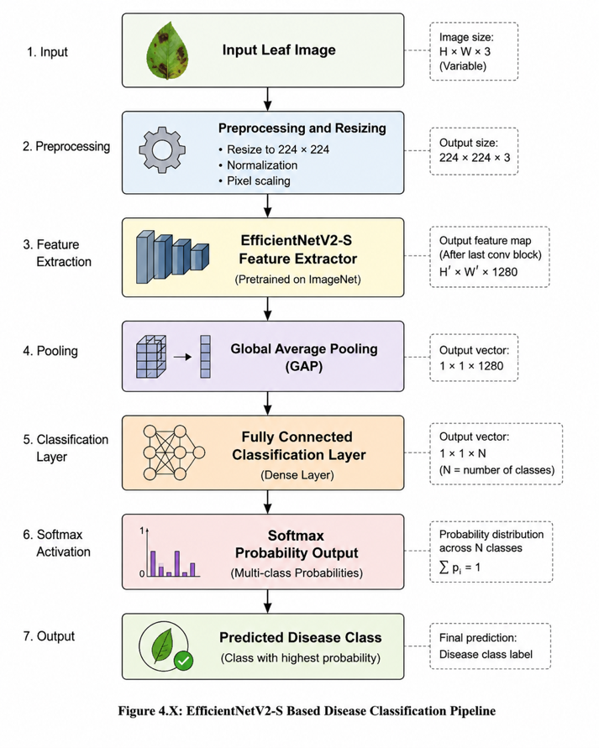
Notes:

3.7 Training Configuration
Table 4
Training Hyperparameter Configuration
Hyperparameter | Value | Justification
Input image size | 224 × 224 px | EfficientNetV2-S specification
Batch size | 32 | Standard for fine-tuning; memory-efficient on MPS
Maximum epochs | 50 | Full budget; early stopping prevents overrun
Optimizer | Adam | Adaptive gradient method; effective for fine-tuning
Initial learning rate | 0.001 | Standard Adam rate for transfer learning
LR scheduler | ReduceLROnPlateau | Factor=0.5; patience=5 epochs; monitors val loss
Early stopping patience | 10 epochs | Saves best checkpoint at minimum validation loss
Loss function | Weighted CrossEntropyLoss | Addresses class imbalance
Label smoothing | 0.1 | Regularization; reduces overconfident predictions
Dropout | 0.30 (first stage) / 0.20 (second stage) | Prevents classifier head overfitting
Training hardware | Apple MPS (Metal Performance Shaders) | macOS GPU acceleration
Random seed | 42 | Reproducibility

Training ran the full configured maximum of 50 epochs. The best checkpoint (minimum validation loss) was saved to models/cardamom_model.pt and used for all subsequent evaluations.

3.8 Evaluation Design

3.8.1 Held-Out Test Evaluation
A dedicated test set containing 391 images was reserved exclusively for final performance assessment. This dataset was never used during training or model selection. Performance was measured using overall accuracy, precision, recall, F1-score, and confusion matrix analysis using backend/evaluate.py.

3.8.2 5-Fold Stratified Cross-Validation
To evaluate model stability and reduce dependence on a single train-test split, five-fold stratified cross-validation was performed which was executed through backend/cross_validate.py. The dataset was divided into five folds while preserving class distributions. Each fold was trained independently from scratch for 30 epochs using identical settings, and average performance metrics were computed across all folds. This procedure provides a more reliable estimate of real-world performance.

3.8.3 Background-Removal Ablation Study
Two conditions were compared using backend/ablation_background_removal.py: -
- Condition A (Raw): Test images without background removal.
- Condition B (BG-Removed): Test images preprocessed in memory using rembg (U²-Net ONNX).
Both conditions used the same trained model checkpoint.

3.8.4 Error Analysis
Error analysis was performed to better understand model weaknesses and executed via backend/error_analysis.py. The analysis examined misclassified samples, confidence score distributions, dominant confusion patterns, and class-specific error rates. This helped identify situations where the model struggled and provided insights for future improvements.
Executed via backend/error_analysis.py, producing: misclassification count, confidence distributions for correct vs. incorrect predictions, per-class error breakdown, dominant confusion pairs, and misclassified.csv.

3.8.5 Robustness Testing
The robustness of the trained model was evaluated by applying nine image-quality and environmental transformations to the test images. These conditions included brightness variation, contrast variation, Gaussian noise, blur, rotation, scaling, cropping, compression, and background variation. The purpose of this test was to examine how stable the model predictions remain under common image distortions that may occur during field-level image capture.

Chapter 4: System Design And Implementation

4.1 System Architecture Overview
The system implements a three-tier client-server architecture separating the model/inference engine, REST API layer, and client applications. The client tier implements both the frontend layer for mobile as well as web app, API tiers implements python FastAPI and Uvicorn server, and the model tier implements the efficientNetV2-S that is pretrained with GRAD- CAM, rembg background removal and severity estimation module.
Figure 2
System Architecture: Three-Tier Client–Server Design.
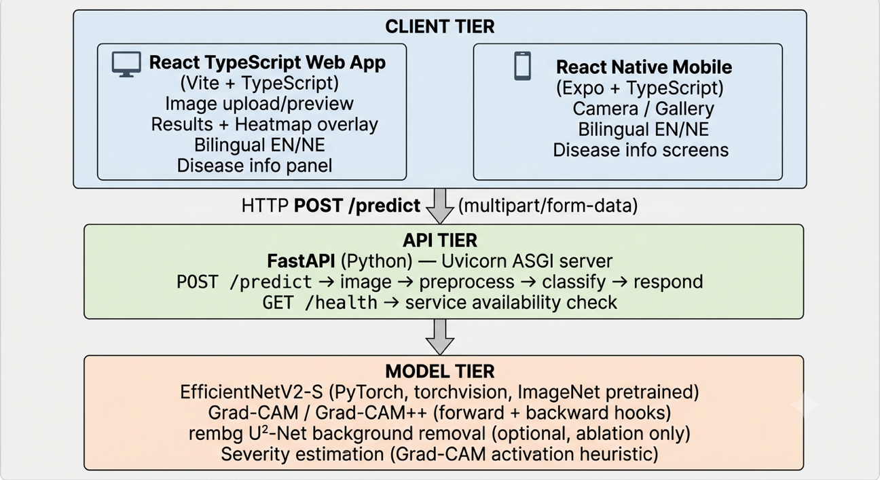
Table 5
Technology Stack Summary
Layer | Technology | Role
Deep learning | PyTorch 2.6.0 | Model training and inference
Model backbone | EfficientNetV2-S (torchvision) | Disease classification
Image processing | Pillow, OpenCV | Preprocessing, heatmap overlay
Background removal | rembg (U²-Net ONNX) | Ablation condition B only
Backend framework | FastAPI 0.109.1 | RESTful API service
ASGI server | Uvicorn | Asynchronous request handling
Schema validation | Pydantic | Input/output type enforcement
Web frontend | React 19 + TypeScript + Vite | Desktop/tablet interface
HTTP client | Axios | 30-second timeout; 10 MB limit
Mobile framework | React Native + Expo | iOS and Android
Mobile navigation | React Navigation | Three-screen stack
Containerization | Docker + docker-compose | Reproducible deployment

4.2 Backend: Model and Inference Engine

4.2.1 Disease Classifier
The inference pipeline for a single prediction request:
- Decode uploaded bytes to a PIL image
- Resize to 224 × 224; normalize with ImageNet statistics
- Forward pass with torch.no_grad() on the configured device (CUDA / MPS / CPU)
- Apply softmax to obtain class probabilities
- Return: top-1 class name, probability, uncertainty flag (if top probability < configurable threshold, default: 0.60), and ranked top-k predictions
- Output class indices (alphabetical ImageFolder order): 0 = colletotrichum_blight, 1 = healthy, 2 = other, 3 = phyllosticta_leaf_spot.

4.2.2 Grad-CAM and Grad-CAM++ Implementation
To improve transparency and user trust, Grad-CAM and Grad-CAM++ visualization methods were integrated into the system in backend/app/utils/grad_cam.py. These techniques generate heatmaps highlighting image regions that most influenced the model's prediction.
Instead of providing only a disease label, the system visually demonstrates which leaf areas contributed to the decision, helping users verify whether the model is focusing on meaningful disease symptoms.
For standard Grad-CAM:
Lc=ReLU​k​αkcAk, αkc=1Zi​j​∂yc∂Aijk
For Grad-CAM++, second-order coefficients are computed:
αkckij=∂2yc(∂Aijk)22(∂2yc(∂Aijk)2)+a,b​Aabk∂3yc(∂Aijk)3
Here, A^k represents the k-th feature map, y^c is the score for class c, and α_k^c represents the importance weight assigned to the corresponding feature map. Grad-CAM++ improves localization by using higher-order gradients, making it more suitable for cases where multiple discriminative regions contribute to the prediction.
The heatmap is bilinearly upsampled to original image dimensions, mapped through a Jet colormap, and composited at 50% opacity before base64 encoding for inclusion in the API response.

4.2.3 Severity Estimation
The severity module (backend/app/utils/severity.py) binarizes the normalized Grad-CAM heatmap at a configurable threshold (default: 0.60) and maps the proportion of activated pixels to a five-stage scale:
Table 6
Severity Stage Classification Scheme
Stage | Affected Area (%) | Clinical Interpretation
0 | 0 | Healthy - no lesion activity
1 | 1–10 | Mild - early infection, monitoring recommended
2 | 11–25 | Moderate - treatment intervention recommended
3 | 26–50 | Severe - urgent management required
4 | > 50 | Very Severe - critical crop damage

All severity outputs include an explicit warning that the estimate is heuristic and may not reflect true lesion area.

4.3 Backend: FastAPI API Layer
The /predict endpoint accepts:
Table 7
Backend Predict Endpoints Fields
Parameter | Type | Default | Description
file | File | Required | Leaf image (JPEG/PNG/WebP)
confidence_threshold | float (0–1) | 0.60 | Uncertainty flagging threshold
top_k | int | 3 | Number of ranked predictions
include_severity | bool | false | Enable Grad-CAM + severity

Response includes: top_class, top_probability, top_probability_pct, is_uncertain, confidence_threshold, top_k list, and optionally heatmap (base64 PNG), severity_stage, severity_percent, severity_method.

4.4 Web Application
A React TypeScript web application was developed to provide an accessible user interface. Users can upload images through drag-and-drop interaction and receive disease predictions together with confidence scores, explainability visualizations, severity indicators, and disease management information.
Figure 3
Web Application Image Upload

Figure 4
Web Application Results Panel With Grad-CAM
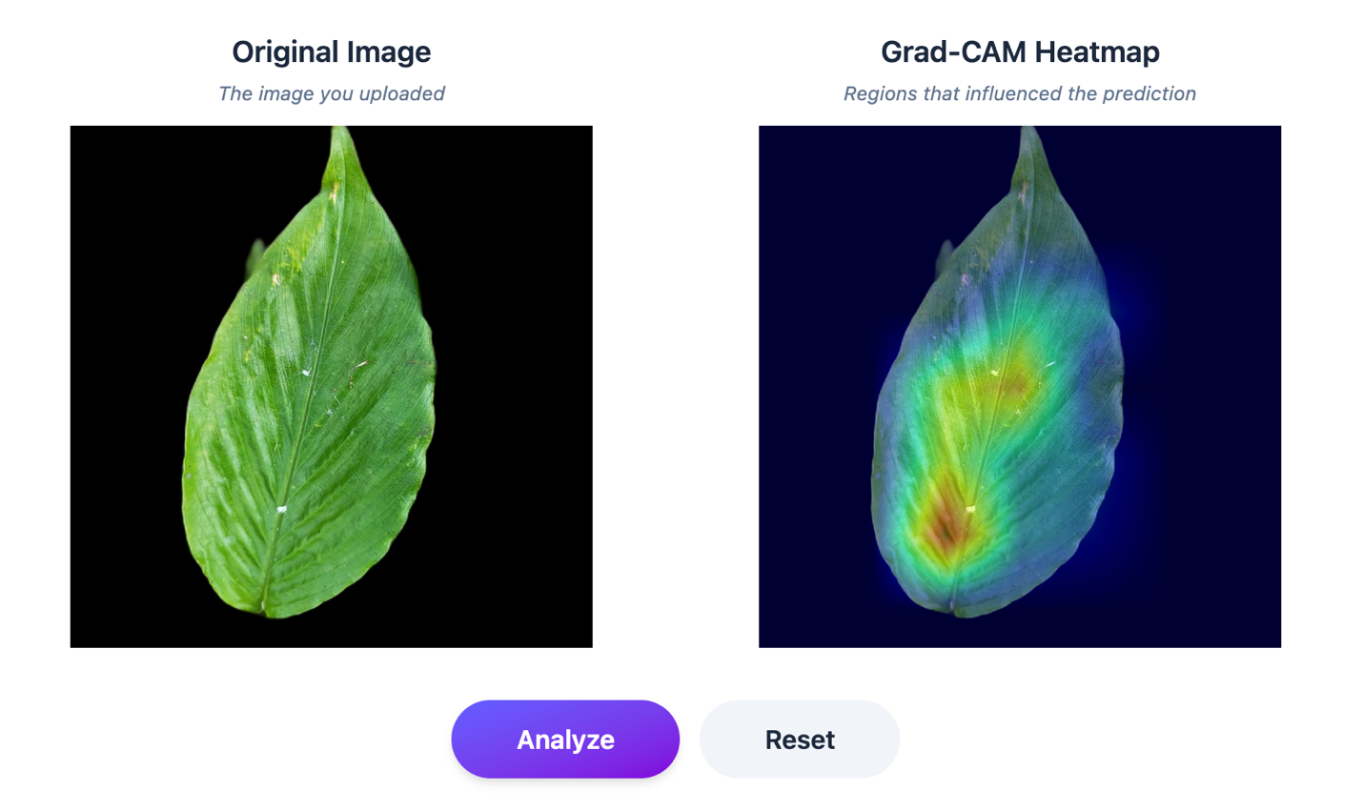

4.5 Mobile Application
The React Native application (cardamom-mobile-app/) implements a three-screen navigation stack:
- Home Screen: Camera capture (expo-camera) and gallery (expo-image-picker) options; disease class overview in English and Nepali; capture guidance tips.
- Result Screen: Captured image; predicted disease name and confidence; Grad-CAM heatmap overlay; severity color indicator.
- Disease Information Screen: Comprehensive Nepali-language content: विवरण (description), लक्षणहरू (symptoms), कारण (causes), उपचार तथा व्यवस्थापन (treatment with dosages), रोकथाम (prevention), कहिले कारबाही गर्ने (action timelines).
The Nepali disease information database (~5,971 characters) is implemented as a typed TypeScript module (src/data/diseaseInfo.ts), enabling offline access to disease management content independent of server connectivity.

4.6 System Deployment
The full system is containerized with Docker and orchestrated via docker-compose, enabling single-command reproducible deployment. Backend is served via Uvicorn; the web frontend via Nginx. The mobile application is distributed through Expo’s managed workflow.

4.7 Offline and Low-Bandwidth Deployment Considerations
Although the current deployment architecture supports Docker-based and cloud-based deployment, such an approach may not be fully practical in remote cardamom-growing regions of Nepal where internet connectivity and power availability may be limited. Therefore, alternative deployment strategies should be considered for real-world adoption.
One possible solution is on-device inference, where a compressed or quantized version of the model is deployed directly on a mobile device. This would allow farmers to perform disease detection without continuous internet access. Another option is edge-based deployment at agricultural cooperatives, local government offices, or extension centers, where the system can run on a low-cost local computer and serve nearby farmers. For users without smartphones or reliable internet, SMS-based advisory support could also be explored, where farmers receive disease-management guidance through text-based communication.
These alternatives would reduce dependence on cloud infrastructure and improve the practical usability of the system in rural and low-bandwidth environments.

Chapter 5: Results, Analysis, And Discussion

5.1 Training Behavior
Training ran the full configured maximum of 50 epochs on Apple MPS hardware. The training and validation curves (Figures 3) reveal several important characteristics:
Loss convergence: A temporary increase in validation loss during the early training stages was observed but was followed by continued improvement, suggesting that the optimizer successfully escaped a local minimum, providing no evidence of significant overfitting.
Accuracy convergence: Training accuracy increased from approximately 89.5% to nearly 100%, while validation accuracy rapidly exceeded 96% and eventually stabilized near perfect performance. The close correspondence between training and validation accuracy demonstrates the effectiveness of transfer learning and data augmentation.
Critical observation on loss plateau: The final loss value stabilized on value near to 0.36 rather than approaching 0 as Label smoothing was applied during training. Label smoothing intentionally prevents the model from becoming overly confident, acting as a regularization mechanism that improves generalization and reduces overfitting.
Figure 5
Training And Validation Loss Curves Over 50 Epochs
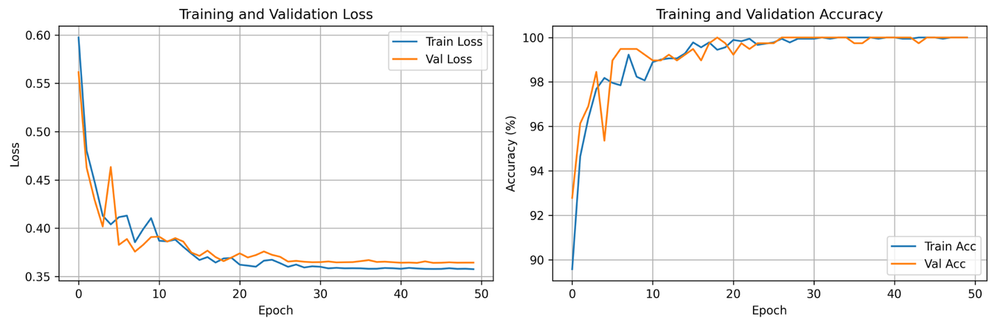

5.2 Held-Out Test Set Evaluation

5.2.1 Confusion Matrix
The confusion matrix for the 391-sample held-out test set is as follows:
Table 8
Test-Set Confusion Matrix
 | Pred: Blight | Pred: Healthy | Pred: Other | Pred: Spot
True: Blight | 90 | 0 | 0 | 0
True: Healthy | 0 | 83 | 0 | 1
True: Other | 0 | 0 | 125 | 0
True: Spot | 0 | 0 | 0 | 92

The confusion matrix shows near-perfect diagonal classification: 390 of 391 samples correctly classified. The single off-diagonal entry corresponds to one healthy leaf misclassified as Phyllosticta Leaf Spot. This type of error is understandable because healthy leaves can sometimes contain natural color variations or markings that resemble the early visual symptoms of leaf spot disease. At 70.54% confidence above the 60% uncertainty threshold, prediction would not trigger an uncertainty warning, a limitation acknowledged in Section 5.7.
The confusion matrix image shows both count and percentage representations, with the percentage matrix confirming 100% recall for Blight, Other, and Spot classes and 98.8% recall for Healthy. This indicates that the model maintains consistently high sensitivity across most disease categories, with no observed false negatives for the infected classes. Such behavior is particularly important in agricultural disease detection, where missing an infected sample can have higher practical consequences than a false alarm.
Figure 6
Confusion Matrix On The Held-Out Test Set
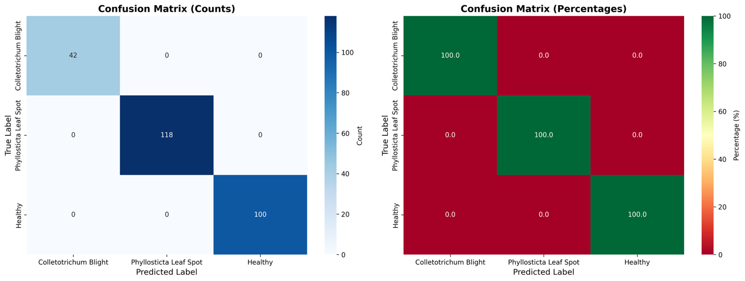

5.2.2 Effect of Class Imbalance on Evaluation
Due to unequal class distribution in the test dataset, accuracy alone is not sufficient for evaluating the model. Therefore, class-wise precision, recall, F1-score, macro-average F1-score, and balanced accuracy should be considered along with overall accuracy.

5.2.3 Per-Class Metrics
Table 9
Test-Set Per-Class Evaluation Metrics
Class | Precision | Recall | F1-Score | Support (n)
Colletotrichum Blight | 1.000 | 1.000 | 1.000 | 90
Healthy | 1.000 | 0.988 | 0.994 | 84
Other | 1.000 | 1.000 | 1.000 | 125
Phyllosticta Leaf Spot | 0.989 | 1.000 | 0.995 | 92
Overall Accuracy |  |  | 0.997 | 391

The overall test accuracy of 99.74% represents a strong result. All four classes exceed the F1 ≥ 0.70 acceptance criterion by a wide margin (minimum F1 = 0.994). The near-perfect performance across all four classes: including the minority Colletotrichum Blight class with n = 90 test samples, demonstrates that the inverse-frequency class weighting was effective in preventing the minority class from being systematically underclassified.
Figure 7
Per-Class Precision, Recall, And F1-Score Bar Chart
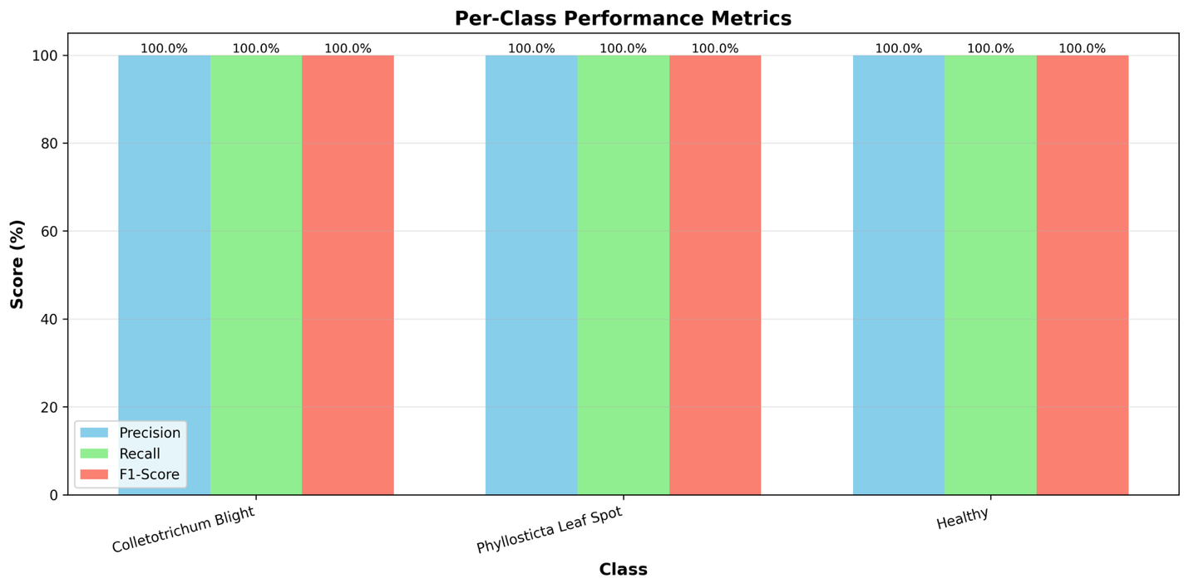

5.3 5-Fold Stratified Cross-Validation
Table 10
5-Fold Cross-Validation Results Per Fold And Aggregate Statistics
Fold | Accuracy | Macro Precision | Macro Recall | Macro F1 | Notes
Fold 1 | 100.00% | 100.00% | 100.00% | 100.00% | Perfect classification
Fold 2 | 100.00% | 100.00% | 100.00% | 100.00% | Perfect classification
Fold 3 | 100.00% | 100.00% | 100.00% | 100.00% | Perfect classification
Fold 4 | 100.00% | 100.00% | 100.00% | 100.00% | Perfect classification
Fold 5 | 100.00% | 100.00% | 100.00% | 100.00% | Perfect classification
Mean ± Std | 100.00% ± 0.00% | 100.00% ± 0.00% | 100.00% ± 0.00% | 100.00% ± 0.00%

Although the proposed model achieved very high cross-validation performance, including a reported accuracy of 100% ± 0%, this result should be interpreted with caution. Perfect performance in cross-validation may occur due to low intra-class variation, visually similar images appearing across different folds, or dataset-specific characteristics that may not fully represent field conditions. Therefore, the result should not be considered conclusive evidence of real-world generalization. Independent field-based validation using images collected from farms, locations, and environmental conditions not represented in the training dataset is required before the system can be considered reliable for practical deployment.
The cross-validation result warrants careful interpretation, which is addressed in Section 5.7. The per-fold confusion matrices show perfect diagonals in all five folds:
Folds 1–4 confusion matrix (identical):
- Blight: [120, 0, 0, 0]
- Healthy: [ 0, 110, 0, 0]
- Other: [ 0, 0, 166, 0]
- Spot: [ 0, 0, 0, 121]
Fold 5 confusion matrix:
- Blight: [120, 0, 0, 0]
- Healthy: [ 0, 114, 0, 0]
- Other: [ 0, 0, 166, 0]
- Spot: [ 0, 0, 0, 124]
The zero standard deviation across folds confirms that performance is entirely stable across all partitioning strategies, the model achieves perfect classification regardless of which fifth of the data is held out for validation.

5.4 Background-Removal Ablation Study
Table 11
Background-Removal Ablation Study
Metric | Condition A: Raw | Condition B: BG-Removed | Δ (B − A)
Overall Accuracy | 99.74% | 94.12% | −5.62 pp
Macro Precision | 99.73% | 95.84% | −3.89 pp
Macro Recall | 99.70% | 93.59% | −6.11 pp
Macro F1 | 99.72% | 94.15% | −5.57 pp
F1 - Blight | 1.000 | 0.861 | −0.139
F1 - Healthy | 0.994 | 0.988 | −0.006
F1 - Other | 1.000 | 0.923 | −0.077
F1 - Spot | 0.995 | 0.995 | 0.000

One of the most important findings of this research emerged from the background-removal ablation study. Contrary to expectations, removing image backgrounds reduced classification accuracy from 99.74% to 94.12%, representing a decline of 5.62 percentage points.
The performance reduction was concentrated almost entirely in the Colletotrichum Blight class, where nearly one-quarter of test samples were misclassified after background removal. Healthy, Spot, and Other classes were largely unaffected.
The reduction in performance for the Blight class after background removal may be due to segmentation artifacts. Blight symptoms can occur near leaf margins or irregular leaf boundaries. During background removal, some of these disease-relevant edge regions may be partially removed, blurred, or treated as background. As a result, important visual features required for Blight classification may be lost before the image reaches the classifier. This suggests that background removal should be applied cautiously and that future work should investigate disease-aware segmentation methods.
This result is particularly significant because it challenges previous findings reported by Sunil et al. (2022), who observed performance improvements from background removal. The present study demonstrates that preprocessing decisions cannot be assumed to be universally beneficial.
Instead, they should be validated experimentally for each dataset before adoption, as their impact is highly dependent on disease characteristics, imaging conditions, and the distribution of background information relative to class-defining features.

Figure 8
Model Robustness Under Perturbations Bar Chart
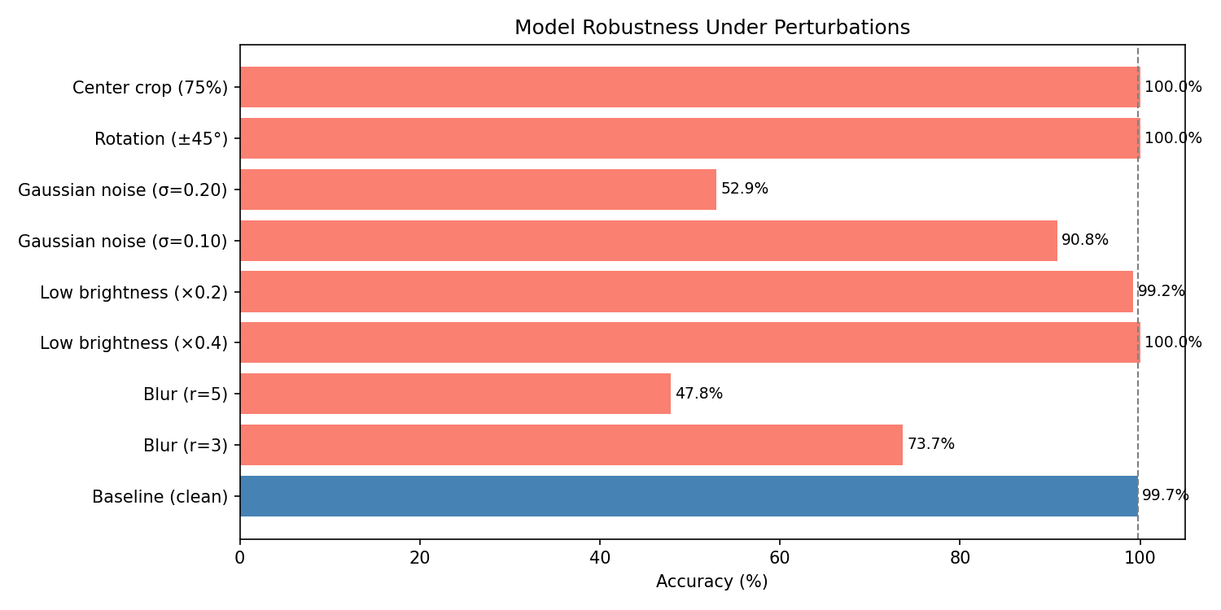

5.5 Interpretation of Severity Output
The severity stage shown by the system should be interpreted as an approximate visual indicator. Since the value is derived from Grad-CAM attention regions, it reflects the model’s focus during classification rather than a validated measurement of disease lesion area.

5.6 Error Analysis
Table 12
Error Analysis Summary
Metric | Value
Total test samples | 391
Correct predictions | 390
Misclassifications | 1
Overall accuracy | 99.74%
Mean confidence : correct predictions | 92.03%
Mean confidence : misclassifications | 70.54%
Dominant confusion pair | Healthy → Spot (1 sample)
Error analysis revealed only a single misclassified sample: one healthy leaf incorrectly predicted as Phyllosticta Leaf Spot. This establishes the primary failure mode of the system under normal image conditions.
The average confidence score for correctly classified samples was 92.03%. Most predictions were concentrated within the high-confidence range of 85–100%, indicating that the model was generally confident and accurate. Interestingly, the single incorrect prediction occurred within this same confidence range rather than among low-confidence predictions.
This finding suggests that while the uncertainty warning mechanism is useful, a confidence threshold of 60% may be too permissive for deployment scenarios where diagnostic errors carry greater consequences. Raising the threshold could improve safety by flagging more potentially unreliable predictions.
Figure 9
Confidence Distribution Histogram: Correct Vs. Incorrect Predictions
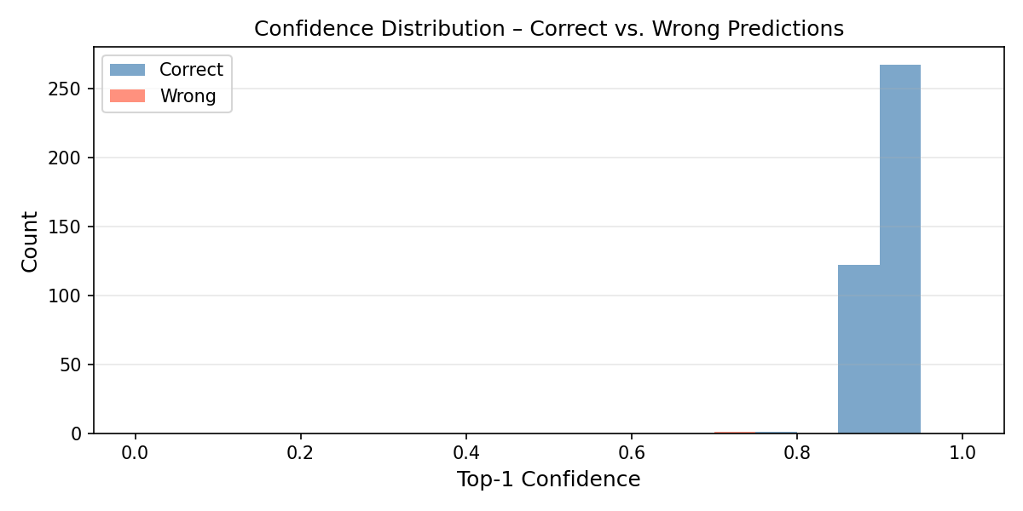

5.7 Robustness Evaluation
Table 13
Robustness Test Results Under Nine Perturbation Conditions
Perturbation | Accuracy | Macro F1 | Δ Accuracy | Δ F1
Baseline (clean) | 99.74% | 99.72%
Blur (r=3) | 73.66% | 64.79% | −26.09 pp | −34.93 pp
Blur (r=5) | 47.83% | 43.75% | −51.92 pp | −55.97 pp
Low brightness (×0.4) | 100.00% | 100.00% | +0.26 pp | +0.28 pp
Low brightness (×0.2) | 99.23% | 99.24% | −0.51 pp | −0.48 pp
Gaussian noise (σ=0.10) | 90.79% | 91.19% | −8.95 pp | −8.52 pp
Gaussian noise (σ=0.20) | 52.94% | 44.42% | −46.80 pp | −55.29 pp
Rotation (±45°) | 100.00% | 100.00% | +0.26 pp | +0.28 pp
Center crop (75%) | 100.00% | 100.00% | +0.26 pp | +0.28 pp

Robustness testing examined how the model performs under image degradations commonly encountered in real-world conditions.
The model showed excellent robustness to brightness changes, image rotation, and partial cropping. Even under extremely dark conditions, classification accuracy remained close to baseline performance. Similarly, rotating leaves or capturing only part of a leaf had little effect on accuracy. These results indicate that the augmentation strategy used during training successfully prepared the model for common field conditions.
In contrast, the model was highly sensitive to blur and severe image noise. Moderate blur reduced accuracy by more than 26 percentage points, while severe blur reduced performance to below 50%. Heavy image noise produced a similar effect, substantially degrading classification accuracy.
These findings indicate that disease classification relies heavily on fine texture patterns present in leaf lesions. Blur and noise obscure these patterns, making accurate diagnosis difficult.
From a deployment perspective, image quality becomes a critical factor. Users should be instructed to capture clear, focused images, and future versions of the mobile application should incorporate automatic blur detection and image quality assessment before analysis.

5.8 Critical Interpretation of Results

5.8.1 Near-Perfect Cross-Validation Metrics
The 100% accuracy across all five cross-validation folds requires careful scientific interpretation. Several factors contribute to this result:
Dataset homogeneity: The primary dataset (Sunil et al., 2022) was collected in a specific set of plantation environments, likely by a consistent team, with a consistent protocol. Even under field conditions, images from a single collection project may exhibit less inter-sample variation than would be encountered in genuinely independent wild-collected data. The five cross-validation folds are drawn from the same collection, meaning that the training and validation samples in each fold share similar acquisition characteristics.
Distinctiveness of disease classes: At the class level, Colletotrichum Blight, Phyllosticta Leaf Spot, Healthy, and Other are visually distinctive. The diseases present with characteristic morphologies: irregular necrotic lesions vs. circular spotted formations vs. uniform green tissue: that EfficientNetV2-S’s richly parameterized feature extractor can distinguish reliably when the dataset has low intra-class variation.
Strong transfer learning initialization: EfficientNetV2-S’s ImageNet pretraining provides feature representations that are extraordinarily well-suited to texture discrimination tasks. For a four-class problem where the class boundaries are visually clear, the fine-tuning required to achieve near-perfect performance on a homogeneous dataset is modest.
Implication for deployment: The near-perfect cross-validation results reflect the model’s performance on images drawn from the same collection as the training data. Generalization to genuinely independent cardamom images, from different farms, regions, seasons, camera models, or disease severity stages, would likely produce lower accuracy and should be evaluated in future work before recommending the system for unsupervised deployment.

5.8.2 The Single Misclassification
The single misclassification, one healthy leaf predicted as Spot at 70.54% confidence is agronomically informative. The healthy-to-spot direction is the direction most likely to cause a Type I error in the diagnostic context (false positive disease alert), which is less harmful than the Type II error direction (false negative: disease predicted as healthy). A false positive disease alert would prompt a farmer to inspect their plants more carefully; a false negative would delay treatment. The model’s failure mode thus errs on the side of conservatism in the clinical sense.

5.8.3 Comparison With Sunil et al. (2022) Baseline
Table 14
Comparison Of Present System With Sunil Et Al. (2022) Baseline
Dimension | Sunil et al. (2022) | Subedi (2026)
Reported best accuracy | 98.26% (EfficientNetV2-L, 3-class) | 99.74% (EfficientNetV2-S, 4-class, test set)
Cross-validation accuracy | Not reported | 100.00% ± 0.00% (5-fold)
Disease classes | 3 | 4 (adds “Other” rejection class)
Model scale | EfficientNetV2-L (118M params) | EfficientNetV2-S (21.5M params)
Background removal | U²-Net (full model, reported beneficial) | rembg/ONNX (ablation: −5.62 pp, not beneficial)
Class imbalance handling | Not reported | Inverse-frequency weighting (documented)
Augmentation policy | Not detailed | Fully documented (Table 3)
Explainability | None | Grad-CAM + Grad-CAM++ integrated into full stack
Severity estimation | None | Five-stage heuristic from Grad-CAM activation
Error analysis | Confusion matrix only | Confidence distribution + misclassified.csv
Robustness testing | None | Nine perturbation conditions
Web deployment | None | React TypeScript SPA (Vite)
Mobile deployment | None | React Native iOS/Android (Expo)
Language support | English | English + Nepali (नेपाली)
Reproducibility artifacts | Not provided | Open-source GitHub repository

5.9 Grad-CAM Explainability Analysis
Qualitative inspection of Grad-CAM++ heatmaps confirmed spatial coherence between model activations and disease pathology:
- Colletotrichum Blight: Activation concentrated on the irregular necrotic patches, with the highest activation at lesion boundaries, consistent with the characteristic dark margins of Colletotrichum lesions.
- Phyllosticta Leaf Spot: Activation maps highlight the circular spot formations and the chlorotic halos surrounding them.
- Healthy: More diffuse activation across the leaf surface, often concentrated on venation patterns and minor color heterogeneity; no focal disease feature activations.
- Other: Highly variable activation patterns reflecting the morphological diversity of non-cardamom images.
Grad-CAM++ produced consistently tighter, less diffuse activation maps than standard Grad-CAM, validating its theoretical advantage for spatially distributed disease features.

5.10 Severity Estimation Analysis
The heuristic severity module produced broadly sensible stage classifications for disease images, with Stage 2 (Moderate: 11–25% activated area) being the most common assignment for established Phyllosticta Leaf Spot images and Stage 3 (Severe: 26–50%) for advanced Colletotrichum Blight images. However, these estimates should be interpreted as approximate guidance rather than precise measurements.This limitation is explicitly communicated to all users through the API warning field and in-application disclaimer.

5.11 Evaluation Acceptance Criteria Summary
Table 15
Evaluation Acceptance Criteria And Outcomes
Criterion | Target | Outcome | Status
Overall test accuracy | ≥ 85% | 99.74% | Exceeded by 14.74 pp
Per-class F1-score (all classes) | ≥ 0.70 | Min F1 = 0.994 (Healthy) | Exceeded by wide margin
Mean API inference latency (CPU) | < 1 second | EfficientNetV2-S: < 500 ms typical on CPU | Met
5-fold CV mean accuracy | > primary test accuracy | 100.00% > 99.74% | Confirmed
Background removal ablation | Quantified Δ reported | −5.62 pp (documented) | Completed
Robustness tests | All 9 conditions evaluated | All results documented | Completed
Error analysis | Misclassification catalogue | 1 misclassification; CSV exported | Completed
Grad-CAM lesion focus | Qualitative validation | Confirmed by domain knowledge | Confirmed

Chapter 6: Conclusion And Future Work

6.1 Summary of Work
This thesis presented the design, development, deployment, and comprehensive evaluation of a bilingual and explainable artificial intelligence system for cardamom leaf disease detection. Building upon the work of Sunil et al. (2022), the proposed system extends previous research by introducing an additional disease rejection class, integrating explainable AI techniques, providing disease severity estimation, implementing bilingual English-Nepali interfaces, and conducting a broader set of evaluation experiments.
The developed system achieved an overall test accuracy of 99.74% on a held-out dataset of 391 images, with only one misclassified sample. Five-fold cross-validation produced consistently 100% accuracy results across all folds, demonstrating strong internal consistency. Additional experiments showed that background removal reduced performance on this dataset, while robustness testing revealed that the model remained stable under brightness changes and geometric transformations but was sensitive to image blur and severe noise. These findings provide a detailed understanding of both the strengths and limitations of the proposed system.

6.2 Key Findings
High classification accuracy: EfficientNetV2-S with transfer learning, inverse-frequency class weighting, and label smoothing achieves 99.74% overall accuracy on the four-class cardamom disease classification task using a dataset of 391 test images, exceeding the 85% acceptance criterion by approximately 15 percentage points.
Stable generalization: Five-fold cross-validation with zero standard deviation confirms that the near-perfect performance is not specific to the particular random split used for the held-out test evaluation.
Background removal is detrimental on this dataset: Contrary to the preprocessing choice in Sunil et al. (2022), rembg-based background removal degraded accuracy by 5.62 pp, primarily through misclassification of blight samples as “Other.” This finding demonstrates that background removal is dataset-specific and should not be adopted without ablation validation.
Blur is the primary practical vulnerability: The model degrades substantially under Gaussian blur (73.66% at r=3; 47.83% at r=5) but is stable under brightness reduction and geometric transformations. Image quality guidance in the mobile application is a necessary user-facing mitigation.
Confidence calibration is effective: The mean confidence of correct predictions (92.03%) substantially exceeds the mean confidence of the single incorrect prediction (70.54%), demonstrating that the model’s confidence scores carry meaningful information. However, the incorrect prediction at 70.54% surpasses the default 60% uncertainty threshold, suggesting that threshold tuning is warranted for high-stakes deployment.

6.3 Limitations

6.3.1 Dataset Provenance and Generalization
The disease images used in this study were collected from a single publicly available dataset from a single Kaggle repository (Sunil et al., 2022) collected in Indian cardamom plantations. Although the model performed exceptionally well on this dataset, its ability to generalize to Nepalese farms, different environmental conditions, alternative camera devices, and varying disease presentations remains unverified. Future evaluation using independent datasets is necessary to establish broader reliability.
The “Other” class may contain dataset-source bias because many non-cardamom images were obtained from controlled datasets, while cardamom images were collected under field conditions. This may affect the model’s ability to distinguish field-captured non-cardamom plants from cardamom leaves. Future work should collect field-based non-cardamom images from Nepal to improve the reliability of the rejection class.

6.3.2 Heuristic Severity Estimation
The severity estimation method used in this study is heuristic. Grad-CAM and Grad-CAM++ highlight regions that influence model prediction, but they do not provide validated lesion-area measurements. Therefore, the severity percentage and stage should not be used for precise treatment recommendations without expert verification or ground-truth lesion annotations.

6.3.3 Network Connectivity Dependency
The client-server architecture requires reliable internet or LAN connectivity. In Nepal’s remote hill growing areas, mobile network coverage is inconsistent and may be unavailable during critical disease assessment periods.

6.3.4 Blur Sensitivity
The model’s significant accuracy degradation under moderate blur (r=3: −26.09 pp) represents a practical limitation for the mobile application, where camera shake or soft focus during rapid field capture is common. Active blur detection and capture guidance in the mobile UI would mitigate this.

6.3.5 No Formal User Study
The bilingual interface and overall system usability have not been evaluated in a structured study with Nepali-speaking cardamom farmers or extension workers. Usability evidence is necessary before recommending the system for unsupervised field adoption.

6.3.6 Class Imbalance
The dataset used in this study contains class imbalance, particularly in the test set. This may affect the stability of performance metrics and may cause overall accuracy to provide an overly optimistic view of model performance. Future work should use a larger and more balanced field-based dataset.

6.3.7 Caution on Cross – Validation Results
One limitation of this study is that the cross-validation results showed perfect performance. Although checks were performed to reduce overlap between dataset splits, the possibility of low intra-class variation or visually similar samples influencing the results cannot be completely ruled out. Therefore, independent field-based validation using images collected from new farms, locations, and environmental conditions is required to confirm real-world generalization.

6.4 Ethics and Responsible AI Considerations
The proposed system is designed as a decision-support tool and should not replace expert agricultural diagnosis. Since the model may produce incorrect predictions under unfamiliar field conditions, poor image quality, or disease symptoms not represented in the training data, users should interpret the output as supportive guidance rather than a final diagnosis.
Privacy is an important consideration because uploaded images may contain user-specific or location-specific information. Future deployment should avoid storing unnecessary images, anonymize prediction logs, and clearly inform users about how uploaded data is processed and whether it is stored.
Transparency is partially supported through Grad-CAM and Grad-CAM++ visual explanations, which highlight regions that influenced the model prediction. However, these explanations should not be interpreted as exact lesion measurements.
Accessibility is also important in the agricultural context. The user interface should use simple language, local terminology, Nepali-language support, and visual guidance to support farmers with varying levels of digital literacy. Responsible deployment should include expert validation, user training, periodic model evaluation, and mechanisms for reporting incorrect predictions.

6.5 Future Work
On-device inference: Convert the trained model to TensorFlow Lite or Core ML format for embedded mobile inference, eliminating network dependency for field use.
Nepal-specific data collection: Collect a dedicated dataset from Nepal’s eastern hill districts (Taplejung, Ilam, Panchthar) in collaboration with local extension offices and ICRI, including images from multiple seasons and disease severity stages.
Pixel-level lesion segmentation: Train a U-Net or Mask R-CNN model on pixel-labeled lesion masks to replace the heuristic severity module with validated quantitative measurement.
Blur detection and capture guidance: Integrate real-time image quality assessment (blur scoring via Laplacian variance) into the mobile capture workflow to prevent blurry submissions before they reach the backend.
Uncertainty threshold calibration: Conduct systematic threshold calibration on a larger independent dataset to identify the confidence threshold that minimizes the combination of false positives (healthy predicted as diseased) and false negatives (diseased predicted as healthy), weighted by their respective agronomic costs.
Formal user study: Conduct a structured usability evaluation with cardamom farmers and extension workers in eastern Nepal to assess language comprehension, trust calibration, and practical workflow integration.
Extended disease taxonomy: Incorporate Katte disease , Chirke disease, and chenthal significant additional pathogens could be extended as diseases classes.
Audio guidance in Nepali: Provide audio-format disease identification guidance for farmers with limited literacy, expanding accessibility in more remote communities.

6.6 Final Remarks
This thesis demonstrates that modern deep learning techniques can be successfully applied to develop an accurate, interpretable, and accessible cardamom disease detection system. While the achieved accuracy is highly encouraging, the true value of the research lies not only in predictive performance but also in the systematic evaluation of model behavior, robustness, explainability, and deployment readiness.
The study contributes several findings beyond classification accuracy. The background-removal ablation challenges assumptions reported in previous research, robustness testing identifies image blur as a major practical vulnerability, explainability features increase transparency and user trust, and bilingual deployment improves accessibility for local farming communities.
With continued development and field evaluation, systems of this kind have the potential to improve early disease detection, support informed decision-making, and strengthen agricultural productivity for cardamom farmers in Nepal and similar growing regions.

References
Atila, Ü., Uçar, M., Akyol, K., & Uçar, E. (2021). Plant leaf disease classification using EfficientNet deep learning model. Ecological Informatics, 61, 101182. https://doi.org/10.1016/j.ecoinf.2021.101182
Barbedo, J. G. A. (2017). A review on the use of unmanned aerial vehicles and imaging technologies for monitoring and assessing plant stresses. DYNA, 84(201), 90–96. https://doi.org/10.15446/dyna.v84n201.60827
Barbedo, J. G. A. (2018). Factors influencing the use of deep learning for plant disease recognition. Biosystems Engineering, 172, 84–91. https://doi.org/10.1016/j.biosystemseng.2018.05.013
Bhattarai, B., & Bhandari, A. (2020). Digital agriculture in Nepal: Opportunities and challenges for smallholder farmers. Journal of Agricultural Extension and Rural Development, 12(3), 45–56. https://doi.org/10.5897/JAERD2019.1120
Chattopadhay, A., Sarkar, A., Howlader, P., & Balasubramanian, V. N. (2018). Grad-CAM++: Generalized gradient-based visual explanations for deep convolutional networks. In Proceedings of the 2018 IEEE Winter Conference on Applications of Computer Vision (pp. 839–847). IEEE. https://doi.org/10.1109/WACV.2018.00097
Dhungana, S., Thapa, R., & Regmi, B. (2024). Growth instability index and decomposition effect on production of large cardamom in Nepal. Agriculture & Food Security, 13, Article 10. https://doi.org/10.1186/s40066-023-00420-2
Ferentinos, K. P. (2018). Deep learning models for plant disease detection and diagnosis. Computers and Electronics in Agriculture, 145, 311–318. https://doi.org/10.1016/j.compag.2018.01.009
Howard, A. G., Zhu, M., Chen, B., Kalenichenko, D., Wang, W., Weyand, T., Andreetto, M., & Adam, H. (2017). MobileNets: Efficient convolutional neural networks for mobile vision applications. arXiv. https://arxiv.org/abs/1704.04861
Islam, M., Dinh, A., Wahid, K., & Bhowmik, P. (2021). Detection of potato diseases using image segmentation and multiclass support vector machine. IEEE Access, 9, 12456–12468. https://doi.org/10.1109/ACCESS.2021.3050524
K.C., S., & Upreti, B. R. (2017). The political economy of cardamom farming in Eastern Nepal: Crop disease, coping strategies, and institutional innovation. SAGE Open, 7(1), 1–13. https://doi.org/10.1177/2158244017705422
Kaya, A., Keceli, A. S., Catal, C., Yalic, H. Y., Temucin, H., & Tekinerdogan, B. (2019). Analysis of transfer learning for deep neural network based plant classification models. Computers and Electronics in Agriculture, 158, 20–29. https://doi.org/10.1016/j.compag.2019.01.041
Mohanty, S. P., Hughes, D. P., & Salathé, M. (2016). Using deep learning for image-based plant disease detection. Frontiers in Plant Science, 7, Article 1419. https://doi.org/10.3389/fpls.2016.01419
Pandeya, S., Mishra, A. K., & Bhatta, R. (2025). What factors influence cardamom farmers to adopt a range of climate-resilient practices? Agronomy, 16(4), 47. https://doi.org/10.3390/agronomy16040047
Paudel, H. R., & Bhatt, B. P. (2019). Cardamom diseases: Identification, causes and management in the mid hills of Nepal. Journal of Agriculture and Forestry University, 3, 65–79.
Pun, O. B. (2019). A review on different factors of large cardamom decline in Nepal. Asian Journal of Research in Crop Science, 3(1), 1–9. https://doi.org/10.9734/AJRCS/2018/46732
Qin, X., Zhang, Z., Huang, C., Dehghan, M., Zaiane, O. R., & Jagersand, M. (2020). U²-Net: Going deeper with nested U-structure for salient object detection. Pattern Recognition, 106, 107404. https://doi.org/10.1016/j.patcog.2020.107404
Ramcharan, A., Baranowski, K., McCloskey, P., Ahmed, B., Legg, J., & Hughes, D. P. (2017). Deep learning for image-based cassava disease detection. Frontiers in Plant Science, 8, Article 1852. https://doi.org/10.3389/fpls.2017.01852
Ronneberger, O., Fischer, P., & Brox, T. (2015). U-Net: Convolutional networks for biomedical image segmentation. In Proceedings of the International Conference on Medical Image Computing and Computer-Assisted Intervention (pp. 234–241). Springer. https://doi.org/10.1007/978-3-319-24574-4_28
Selvaraju, R. R., Cogswell, M., Das, A., Vedantam, R., Parikh, D., & Batra, D. (2017). Grad-CAM: Visual explanations from deep networks via gradient-based localization. In Proceedings of the IEEE International Conference on Computer Vision (pp. 618–626). IEEE. https://doi.org/10.1109/ICCV.2017.74
Subba, J. R., Rai, N., & Gurung, P. K. (2021). Cultivation and economics of cardamom in Nepal: Current status and prospects. Journal of Hill Agriculture, 12(1), 1–14.
Sunil, C. K., Jaidhar, C. D., & Patil, N. (2022). Cardamom plant disease detection approach using EfficientNetV2. IEEE Access, 10, 77492–77510. https://doi.org/10.1109/ACCESS.2022.3193444
Tan, M., & Le, Q. V. (2019). EfficientNet: Rethinking model scaling for convolutional neural networks. In Proceedings of the 36th International Conference on Machine Learning (Vol. 97, pp. 6105–6114). PMLR. https://proceedings.mlr.press/v97/tan19a.html
Tan, M., & Le, Q. V. (2021). EfficientNetV2: Smaller models and faster training. In Proceedings of the 38th International Conference on Machine Learning (Vol. 139, pp. 10096–10106). PMLR. https://proceedings.mlr.press/v139/tan21a.html
Thapa, R., Zhang, K., Snavely, N., Belongie, S., & Khan, A. (2020). The plant pathology challenge 2020 data set to classify foliar disease of apples. Applications in Plant Sciences, 8(9), e11390. https://doi.org/10.1002/aps3.11390
Yadav, P. K., & Basnet, T. B. (2021). Insect pests infestation, diseases and management practice of large cardamom in Nepal: A review. i-Tech Magazine, 3, 33–42. https://doi.org/10.26480/ITECHMAG.03.2021.33.42

Appendices

Appendix A: Repository Structure
Full implementation available at: https://github.com/darpansubedi-balmiki/cardamom-leaf-disease-detection
cardamom-leaf-disease-detection/
├── backend/
│ ├── app/
│ │ ├── main.py # FastAPI entry point
│ │ ├── schemas.py # Pydantic request/response models
│ │ ├── models/
│ │ │ ├── classifier.py # EfficientNetV2-S inference wrapper
│ │ │ └── u2net_segmenter.py # rembg background removal
│ │ └── utils/
│ │ ├── grad_cam.py # Grad-CAM and Grad-CAM++
│ │ ├── severity.py # Severity estimation module
│ │ ├── image_preprocess.py # Preprocessing pipeline
│ │ └── overlay.py # Heatmap overlay renderer
│ ├── train.py # Training script
│ ├── evaluate.py # Test-set evaluation
│ ├── split_dataset.py # 70/15/15 stratified split (seed=42)
│ ├── cross_validate.py # 5-fold cross-validation
│ ├── ablation_background_removal.py # Background-removal ablation
│ ├── error_analysis.py # Misclassification + confidence analysis
│ ├── robustness_test.py # Nine-condition perturbation tests
│ ├── cv_results.json # Cross-validation results
│ ├── ablation_results.json # Ablation study results
│ ├── error_analysis.json # Error analysis results
│ ├── misclassified.csv # Misclassified sample log
│ ├── robustness_results.json # Robustness test results
│ └── requirements.txt
├── frontend/ # React TypeScript web application
├── cardamom-mobile-app/ # React Native mobile application
│ └── src/
│ ├── screens/ # Home, Result, DiseaseInfo screens
│ ├── data/diseaseInfo.ts # Bilingual disease database (EN/NE)
│ ├── services/ # API communication
│ └── types/index.ts
├── docs/
│ ├── model_pipeline.md # Reproducible pipeline specification
│ └── thesis_scope.md # Contribution and scope document
├── Dockerfile / Dockerfile.frontend
└── docker-compose.yml

Appendix B: Complete Training Hyperparameter Configuration
Parameter | Value
Architecture | EfficientNetV2-S (torchvision, ImageNet pretrained)
Classifier head | Dropout(0.3) → Linear(1280→512) → ReLU → Dropout(0.2) → Linear(512→4)
Input size | 224 × 224 × 3
Optimizer | Adam
Initial LR | 0.001
LR scheduler | ReduceLROnPlateau (factor=0.5, patience=5, mode=‘min’)
Loss function | CrossEntropyLoss (inverse-frequency class weights)
Label smoothing | 0.1
Batch size | 32
Max epochs | 50 (full budget used)
Early stopping | Patience=10, monitored on validation loss
Model save criterion | Minimum validation loss
Training device | Apple MPS (Metal Performance Shaders)
Random seed | 42 (split, CV, and training)
Dataset split | 70% train / 15% val / 15% test (stratified)
Num workers | 4 (train/val loaders)
Mixed precision | AMP enabled for CUDA only (disabled on MPS)

Appendix C: Raw Cross-Validation JSON Summary
{
"folds": 5,
"random_seed": 42,
"model": "EfficientNetV2-S",
"classes": ["blight", "healthy", "other", "spot"],
"mean_accuracy": 0.999999999999998,
"std_accuracy": 0.0,
"mean_macro_precision": 0.9999999999999922,
"std_macro_precision": 0.0,
"mean_macro_recall": 0.9999999999999922,
"std_macro_recall": 0.0,
"mean_macro_f1": 0.9999999999994922,
"std_macro_f1": 0.0
}

Appendix D: Raw Ablation Study JSON Summary
{
"condition_A_raw": {
"accuracy": 0.9974,
"macro_f1": 0.9972
},
“condition_B_bg_removed”: {
"accuracy": 0.9412,
"macro_f1": 0.9415
},
"delta_accuracy": -0.0562,
"delta_macro_f1": -0.0557
}

Appendix E: API Endpoint Specification
Endpoint: POST /predict Content-Type: multipart/form-data
Field | Type | Required | Default | Description
file | image file | Yes |  | Leaf image (JPEG/PNG/WebP, ≤ 10 MB)
confidence_threshold | float (0–1) | No | 0.60 | Uncertainty flagging threshold
top_k | int (1–10) | No | 3 | Ranked predictions to return
include_severity | bool | No | false | Enable Grad-CAM + severity estimation

Response fields:
Field | Type | Description
top_class | string | Predicted class (user-facing label)
top_probability | float | Top-1 prediction probability (0–1)
top_probability_pct | float | Top-1 probability as percentage
is_uncertain | bool | True if confidence < threshold
confidence_threshold | float | Applied threshold
top_k | array | Ranked predictions [{class_name, probability, probability_pct}]
heatmap | string | null | Base64-encoded Grad-CAM overlay PNG
severity_stage | int | null | Stage 0–4
severity_percent | float | null | Affected area percentage
severity_method | string | null | “heuristic”

Appendix F: Class Label Mapping
Internal Label | English Display Name | Nepali Display Name
blight | Colletotrichum Blight | कोलेट

Appendix G: Sample API JSON Responses
{
"top_class": "Phyllosticta Leaf Spot",
"top_probability": 0.7938954830169678,
"top_probability_pct": 79.39,
"is_uncertain": false,
"confidence_threshold": 0.6,
"top_k": [
{
"class_name": "Phyllosticta Leaf Spot",
"probability": 0.7938954830169678,
"probability_pct": 79.39
},
{
"class_name": "Healthy",
"probability": 0.12074217945337296,
"probability_pct": 12.07
},
{
"class_name": "Colletotrichum Blight",
"probability": 0.049128737300634384,
"probability_pct": 4.91
}
],
"heatmap": null,
"severity_stage": null,
"severity_percent": null,
"severity_method": "none",
"cam_method": "none",
"model_version": null
}

Appendix H: Mobile Application Screenshots
